Filed by Fidelity National Information Services, Inc.

Commission File No. 001-16427

pursuant to Rule 425 of the Securities Act of 1933

and deemed filed under Rule 14a-12 of the

Securities Exchange Act of 1934, as amended

Subject Company: Worldpay, Inc.

Commission File No. 001-35462
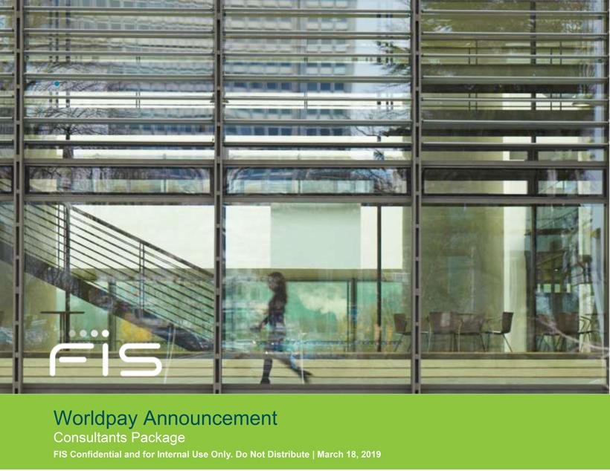

Consultants Talking Points

- On March 18, FIS announced that it has signed a definite agreement to acquire Worldpay.

- Combined, and upon close, our focus will remain on servicing global, regional, community and credit union financial institutions as well as capital markets, retailers and businesses.

- The addition of Worldpay will bring new solutions, services and talent that enhance our current offerings including significant scale in merchant acquiring services.

- We will provide additional details as the acquisition progresses. We expect the transaction to close later this year.

Consultants FAQs

- What did FIS announce?

FIS announced on March 18 that it has signed a definitive agreement to acquire Worldpay (NYSE: WP). Under the terms of the agreement, FIS will acquire 100 percent of the equity of Worldpay. The combined company will have approximately $12.3 billion pro forma 2018 annual revenue.

- Who is Worldpay?

As the No. 1 global acquirer of transactions, Worldpay is one of the world’s leading merchant acquiring and e-commerce payment technology companies, with annual revenue of $3.9 billion. The company’s more than 8,000 employees provide solutions for financial institutions, retailers and businesses offering a comprehensive suite of payment products and services, delivered globally. It processes over 40 billion transactions annually for more than one million merchant locations globally, supporting over 300 payment types across more than 140 countries in over 120 currencies.

- Why did FIS enter into this merger?

This is a tremendous milestone bringing together two great companies with similar business models, complementary solutions and highly talented employees who are dedicated to serving the financial services industry and accelerating the future of finance and commerce.

Combined, our focus will remain on servicing global, regional, community and credit union financial institutions as well as capital markets, retailers and businesses. Upon closing, the addition of Worldpay will bring new solutions, services and talent that enhance our current client offerings including significant scale in merchant acquiring services. Our clients will benefit from our greatly expanded ability to provide merchant acquiring capabilities, as well as other payment offerings. Worldpay’s strong business leaders and talented employees will bring valuable insights and experience to our global team. In addition, this combination enables us to address the following objectives:

- Global Growth Leader at Scale – The combination of industry-leading technology platforms and global distribution channels serving high-growth markets will immediately accelerate the revenue-growth profile of FIS and create meaningful growth opportunities across commerce communities.

- Innovating to Accelerate Growth – Our combined solutions will enhance our growth prospects. FIS is the largest global provider dedicated to financial technology solutions. Worldpay is the No. 1 global merchant acquirer. The combination makes us a powerful global leader in financial technology and payment solutions.

- Financial Strength – The combined company will have approximately $12.3 billion pro forma 2018 annual revenue and a solid outlook for 2019. Increased cash flow will allow us to fund growth opportunities and to further pay down our debt.

www.fisglobal.com | 2

- How does this combination compare to Fiserv’s announced merger with First Data?

We do not comment on competitor transactions. Our combination is driven by our long-term strategy to increase our global scale, expand our portfolio and enter complementary new markets. We have followed Worldpay’s success for several years and felt this was the right time to make this move.

- When will the transaction close?

We expect the transaction to close later this year.

- How will our clients benefit from this transaction?

FIS and Worldpay lead our respective markets in modernization investments. Upon closing, our clients will have access to a wider portfolio of modern digital assets that can help them accelerate growth, streamline operations and better engage with their customers.

The FIS and Worldpay payment solution portfolios are very complementary. As a result, and upon closing, FIS will be uniquely positioned to accelerate the future of finance and commerce globally through the industry’s broadest range of enterprise banking and payments capabilities that empower financial institutions, retailers, capital markets and businesses worldwide. The addition of Worldpay will bring new solutions, services and talent that enhance our current client offerings including significant scale in merchant acquiring services.

- Will our name, leadership or headquarters change?

The combined company will operate under the FIS name and will be headquartered in Jacksonville, Fla. FIS chairman, president and CEO, Gary Norcross, will be chairman, president and CEO of the combined company.

Worldpay’s executive chairman and CEO, Charles Drucker, will become executive vice chairman of the FIS board of directors. He will also assist with our focused efforts to improve our organic growth.

We will be streamlining and simplifying our organizational structure around financial institutions, capital markets and retail payments. Our Retail Payments business will operate under the Worldpay name.

www.fisglobal.com | 3

- Will there be an impact on product offerings?

Upon closing, FIS will be uniquely positioned to accelerate the future of finance and commerce globally through the industry’s broadest range of enterprise banking and payments capabilities that empower financial institutions, retailers, capital markets and businesses worldwide. The addition of Worldpay will bring new solutions, services and talent that enhance our current client offerings including significant scale in merchant-acquiring services.

Consultants Call Script

Hello, this is [Name] calling from FIS.

You may have seen the announcement [today/yesterday] that FIS has entered into an agreement to combine with Worldpay.

This is an important milestone and we are excited because the combined company will have greater abilities to enhance scale, improve the value we offer our clients and drive reinvestment in innovative solutions. Bringing these market-leading companies together positions FIS for future growth and long-term success.

The agreement contains the customary closing conditions, including regulatory and shareholder approvals. We expect the transaction to close later this year. There are no assurances regarding the exact closing date, so we will keep you apprised of updates as we have them available.

If leaving voice mail message, include: “If you have any questions, please call me directly at XXX.XXX.XXXX.”

Consultants Letter

March 18, 2019

Dear [Consultant]:

I hope you have heard the exciting news that FIS™ has signed a definitive agreement to acquire Worldpay. This is a tremendous milestone for FIS, bringing together two great companies with similar business models, complementary solutions and highly talented employees who are dedicated to serving the financial services industry and accelerating the future of finance and commerce.

The FIS and Worldpay payment solutions are very complementary. Upon closing, the addition of Worldpay will bring new solutions, services and talent that enhance our current client offerings including significant scale in merchant acquiring services. Specifically, our clients will benefit from our greatly expanded issuer and merchant capabilities, as well as our new acquiring and unified payment offerings. Worldpay’s strong business leaders and talented employees will bring valuable insights and experience to our global team.

The combined company will continue to operate under the FIS name and be headquartered in Jacksonville, Fla. Gary Norcross will continue to serve as chairman, president and CEO. Charles Drucker, current Worldpay executive chairman and CEO, will become executive vice chairman of the combined companies’ board of directors upon closing. We will be streamlining and simplifying our organizational structure around financial institutions, capital markets and retail payments. Our Retail Payments business will operate under the Worldpay name.

www.fisglobal.com | 4

The transaction is subject to all regulatory and shareholder approvals and contractual closing conditions, and we expect the transaction to close later this year. Until closing, we will continue to conduct business as usual as separate, independent companies and our relationship with you as well as your communication channels and contacts within FIS remain unchanged.

We are limited in the information we can share with you until the transaction closes and look forward to discussing additional details with you at the appropriate time.

As always, we thank you for your continued support of our organization.

Regards,

/s/ Leah Middlebrook

Leah Middlebrook

Sr. Director Consulting Relations

Forward-looking Statements

The statements contained in this document that are not purely historical are forward-looking statements within the meaning of Section 27A of the Securities Act of 1933, as amended, or “Securities Act” and Section 21E of the Securities Exchange Act of 1934, as amended, or “Exchange Act,” including statements regarding our expectations, hopes, intentions, or strategies regarding the future. These statements relate to, among other things, business and market conditions, outlook and our future financial and operating results and debt. In many cases, you can identify forward-looking statements by terminology such as “may,” “will,” “should,” “expect,” “plan,” “anticipate,” “believe,” “estimate,” “predict,” “potential,” or “continue,” or the negative of these terms, and other comparable terminology. Actual results could differ materially from those anticipated in these statements as a result of a number of factors, including, but not limited to:

- the risk that the transaction described herein will not be completed or will not provide the expected benefits, or that we will not be able to achieve the cost or revenue synergies anticipated;

- the risk that the integration of FIS and Worldpay will be more difficult, time-consuming or expensive than anticipated;

- the risk of customer loss or other business disruption in connection with the transaction, or of the loss of key employees;

- the possible occurrence of an event, change or other circumstance that would give rise to the termination of the merger agreement;

- the fact that unforeseen liabilities of FIS or Worldpay may exist;

- the risk of doing business internationally;

- changes in general economic, business and political conditions, including the possibility of intensified international hostilities, acts of terrorism, changes in either or both the United States and international lending, capital and financial markets and currency fluctuations;

www.fisglobal.com | 5

- the effect of legislative initiatives or proposals, statutory changes, governmental or other applicable regulations and/or changes in industry requirements, including privacy and cybersecurity laws and regulations;

- the risks of reduction in revenue from the elimination of existing and potential customers due to consolidation in, or new laws or regulations affecting, the banking, retail and financial services industries or due to financial failures or other setbacks suffered by firms in those industries;

- changes in the growth rates of the markets for the solutions of FIS and Worldpay;

- failures to adapt such solutions to changes in technology or in the marketplace;

- internal or external security breaches of systems, including those relating to unauthorized access, theft, corruption or loss of personal information and computer viruses and other malware affecting our software or platforms, and the reactions of customers, card associations, government regulators and others to any such events;

- the risk that implementation of software (including software updates) for customers or at customer locations or employee error in monitoring software and platforms may result in the corruption or loss of data or customer information, interruption of business operations, outages, exposure to liability claims or loss of customers;

- the reaction of current and potential customers to communications from us or regulators regarding information security, risk management, internal audit or other matters;

- competitive pressures on pricing related to the decreasing number of community banks in the U.S., the development of new disruptive technologies competing with one or more of our solutions, increasing presence of international competitors in the U.S. market and the entry into the market by global banks and global companies with respect to certain competitive solutions, each of which may have the impact of unbundling individual solutions from a comprehensive suite of solutions we provide to many of our customers;

- the failure to innovate in order to keep up with new emerging technologies, which could impact the merged companies’ solutions and ability to attract new, or retain existing, customers;

- the failure to meet financial goals to grow business in Brazil after the unwinding of FIS’s Brazilian Venture;

- the risks of reduction in revenue from the loss of existing and/or potential customers in Brazil after the unwinding of FIS’s Brazilian Venture;

www.fisglobal.com | 6

- an operational or natural disaster at one of our major operations centers; and

- other risks detailed elsewhere in the two companies’ annual reports on Form 10-K for the year ended December 31, 2018 and in our and their other filings with the Securities and Exchange Commission.

Other unknown or unpredictable factors also could have a material adverse effect on our business, financial condition, results of operations and prospects. Accordingly, readers should not place undue reliance on these forward-looking statements. These forward-looking statements are inherently subject to uncertainties, risks and changes in circumstances that are difficult to predict. Except as required by applicable law or regulation, we do not undertake (and expressly disclaim) any obligation and do not intend to publicly update or review any of these forward-looking statements, whether as a result of new information, future events or otherwise.

Additional Information and Where to Find It

This communication is being made in respect of the proposed merger transaction between Fidelity National Information Services, Inc. (“FIS”) and Worldpay Inc (“Worldpay”). In connection with the proposed merger, FIS will file with the SEC a registration statement on Form S-4 that will include the joint proxy statement of FIS and Worldpay and a prospectus of FIS, as well as other relevant documents regarding the proposed transaction. A definitive joint proxy statement/prospectus will also be sent to FIS shareholders and Worldpay stockholders. INVESTORS ARE URGED TO READ THE REGISTRATION STATEMENT AND THE JOINT PROXY STATEMENT/PROSPECTUS REGARDING THE MERGER WHEN IT BECOMES AVAILABLE AND ANY OTHER RELEVANT DOCUMENTS FILED WITH THE SEC, AS WELL AS ANY AMENDMENTS OR SUPPLEMENTS TO THOSE DOCUMENTS, BECAUSE THEY WILL CONTAIN IMPORTANT INFORMATION.

A free copy of the joint proxy statement/prospectus, as well as other filings containing information about FIS and Worldpay, may be obtained at the SEC’s website (http://www.sec.gov). You will also be able to obtain these documents, free of charge, from FIS at www.fisglobal.com or by emailing info.investorrelations@fisglobal.com or from Worldpay by accessing Worldpay’s website at http://investor.worldpay.com or by emailing IR@worldpay.com.

Participants in the Solicitation

FIS and Worldpay and certain of their respective directors and executive officers may be deemed to be participants in the solicitation of proxies from FIS shareholders and Worldpay stockholders in respect of the transaction described in the joint proxy statement/prospectus. Information regarding FIS’s directors and executive officers is contained in FIS’s Proxy Statement on Schedule 14A, dated April 20, 2018, which is filed with the SEC. Information regarding Worldpay’s directors and executive officers is contained in Worldpay’s Proxy Statement on Schedule 14A, dated April 4, 2018, which is filed with the SEC. Additional information regarding the interests of those participants and other persons who may be deemed participants in the transaction may be obtained by reading the joint proxy statement/prospectus regarding the proposed merger when it becomes available. Free copies of this document may be obtained as described in the preceding paragraph.

www.fisglobal.com | 7

This communication does not constitute an offer to sell or the solicitation of an offer to buy any securities or a solicitation of any vote or approval, nor shall there be any sale of securities in any jurisdiction in which such offer, solicitation or sale would be unlawful prior to registration or qualification under the securities laws of such jurisdiction. No offering of securities shall be made except by means of a prospectus meeting the requirements of Section 10 of the Securities Act of 1933, as amended.

Consultants Email Cover Letter

March 18, 2019

Dear Leah:

The attached packet is being provided to you in support of today’s announcement regarding FIS signing a definitive agreement to acquire Worldpay.

Your package contains a letter in Word format that you and your team can personalize and send to your consultant contacts. When you send the letter, you must include the paragraphs displayed at the end of the letter (Forward Looking Statements, Additional Information and Where to Find It, and Participants in the Solicitation).

The FAQs within the package are for your personal use to discuss the transaction and must not be forwarded to your contacts or anyone outside the FIS organization.

Thank you for taking the time to communicate this exciting news to your key contacts. We’ll equip you with more information as it becomes available.

FIS Corporate Communications

www.fisglobal.com | 8

